OR
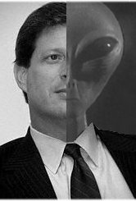
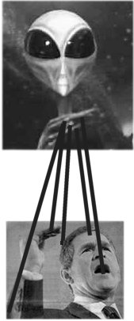

Sometimes they like to make us think we have choices

Earth Day 2001 ATHENA

