WANTED

Dead or Alive

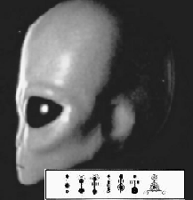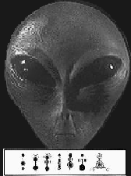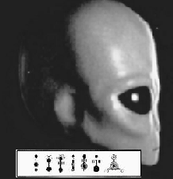

Name: Sectoid

Aliases: Grey, Extraterrestrial

Crimes: Kidnapping, Livestock Mutilation, Theft, Harassment, Use of psionics without permit, Crop Vandalism, Murder, Destruction of Property, Invasion of Privacy, Battery, Loitering, Trespassing on OUR PLANET, Illegal use of rectal probe.

Description

Race: Sectoid
Gender: None visible
Eyes: Black
Skin: Grey
Hair: None

Armed with plasma weaponry. Extremely dangerous. Shoot on sight.
Beware of psionic attacks.

Earth Day 2001 A.T.H.E.N.A

